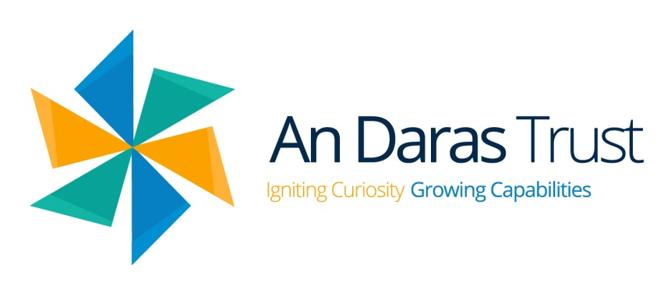
An Daras Multi Academy Trust

Data Privacy Notice for Parents and Carers – Use of Parent/Carer Data

Version: 1.4
Last Updated: 14/05/2026

We, An Daras Multi Academy Trust registered at Unit 4 Tamar Business Park, Pennygillam Way, Pennygillam Industrial Estate, Launceston, Cornwall, PL15 7ED, are the ‘Data Controller’ for the purposes of UK data protection law. Our Data Protection Officer is Glyn Pascoe (see ‘Contact us’ section below).

What is a ‘privacy notice’?

It’s your right under UK data protection law for you to be informed about how organisations use your data. A privacy notice is often called a ‘fair processing notice’ and is designed to inform individuals when data about them is collected, held and processed. This privacy notice is designed to explain how we collect, store and process parent / carer data.

Typical examples of personal data are:

- Contact details such as name, address, phone numbers, email addresses
- Date of birth
- Gender
- Family circumstances
- Safeguarding information including court orders or professional involvement
- Correspondence and contact with us including complaints you have made
- CCTV images captured on our sites (non facial recognition)
- Safeguarding information
- Usage data relating to interactions with our IT systems

The above list should be viewed as a non-exhaustive list and additional data may be stored where it is deemed relevant. Information may also be received from other organisations such as schools, authorities or the DfE (Department for Education). In addition, certain ‘special categories’ of more sensitive data may also be stored, including (but not limited to):
- Health data, both physical and mental
- Details of any support provision with third parties such as social services or external bodies
- Ethnicity and languages spoken
- Eligibility for benefits
- Faith schools may collect religion as part of admission arrangements

What is the purpose of holding the data?

- To help support pupil learning and development by reporting progress
- To provide pastoral care and keep you informed
- To process any financial transactions and payments
- To ensure pupil welfare and safeguarding
- To comply with the relevant laws around data sharing and statutory reporting
- To assess and improve the quality of our teaching and support systems
- To carry out research

Use of personal data in automated decision making and profiling?

We do not process any personal data through automated decision making or profiling.

Use of personal data for marketing

Where you have given us permission, we may send you information by email, text or post promoting events, campaigns, charitable causes or services that we believe may be of interest to you. You are able to withdraw your consent, known as ‘opting out’ of these communications at any time, either by following unsubscribe instructions or by contacting our DPR email account to formally withdraw your permission.

What is our lawful purpose?

Data must only be collected and processed when allowable by law. Typically this is when:

- We are required to process data to deliver our service as a Multi Academy Trust
- We are required to hold data to comply with legal obligations
- It is in the public interest to do so

Where we process your personal data to safeguard the welfare of pupils or to respond to an emergency, we may rely on 'recognised legitimate interests' as our lawful basis under the Data (Use and Access) Act 2025. This means we can share necessary personal data quickly in urgent situations without needing to complete a separate balancing test. We will always limit any sharing to what is strictly necessary.

In addition to the above, it is allowable to hold/process personal data when we have received consent to do so and/or the data allows us to protect your child’s or someone else’s vital interests.

Some of the reasons listed above for collecting and using your personal data may overlap, and there may be several grounds which justify our use of this data.

What is our basis for using special category data?

We only collect, store and process special category data when we have both a lawful basis and one of the below conditions for processing as set out in UK data protection law:
- Explicit consent has been obtained
- Protecting an individual’s vital interests in emergency cases where you are physically or legally incapable of giving consent
- The data has already been made public by you
- Processing for legal claims
- Processing it for substantial public interest as defined in legislations
- Processing for health or social care purposes, and the processing is done by or under the direction of a health or social work professional or by another person obliged to confidentially under law
- Processing for public health reasons, and the processing is done by or under the direction of a health professional or by another person obliged to confidentially under law
- Processing for archiving purposes, scientific or historical research purposes or for statistical purposes and the processing is in the public interest.
- Performing an obligation or right in relation to employment, social security or social protection law

Criminal offence data is only collected, stored and processed when we have both a lawful basis and one of the below conditions for processing as set out in UK data protection law:
- Consent has been obtained
- Protecting an individual’s vital interests in emergency cases where you are physically or legally incapable of giving consent
- The data has already been made public by you
- Processing it for or in connection with legal proceedings, to obtain legal advice or exercise or defence of establishment legal rights
- Processing for reasons of substantial public interest as defined in legislation

How is information collected?

Personal data will fall into two categories: mandatory (in as much as you must comply with the request to provide the data) and optional (where there is a choice whether to supply information or not). As a Data Controller, we must highlight to you which of the above scenarios is applicable.

Most of the data we hold about you will come from you, but we may also hold data about you from:
- Local authorities
- Government departments or agencies
- Your children
- Police, courts, tribunals

How is data stored?

Personal data is kept secure and is retained for the duration of your child’s attendance at our Multi Academy Trust. Certain data may be retained after the pupil leaves the Multi Academy Trust in order to comply with our legal obligations. The data will be subject to our standard retention period followed by secure disposal.

A copy of this schedule can be obtained from The Information and Records Management Society’s Toolkit for Schools.

How we share your data?

Data will not be shared with any third party without consent unless either allowable by law or indicated as part of our policies. Assuming either of the above apply, data can be shared with:
- Central government and our local authority (Cornwall or Devon) – to meet our legal obligations to share certain information
- The Department for Education – to meet our legal obligations to share certain information
- Educators and examining bodies – to meet our legal obligations and to support pupil learning
- Our regulator Ofsted – to meet our legal obligations
- Suppliers and service providers – to enable them to provide the service we have contracted them for such as parent contact information for text/SMS/app messaging services
- Financial organisations – to enable them to provide the service we have contracted them for, such as bank account details to enable paying of invoices
- Health authorities – to provide appropriate pastoral care and to protect pupil welfare, such as attendance and medical conditions
- Health and social welfare organisations – to meet our legal obligations and to provide appropriate pastoral care and to protect pupil welfare, such as attendance, attainment and medical conditions
- Professional advisers and consultants – to support pupil learning and enable them to provide the service we have contracted them for, such as progress, attainment and attendance
- Charities and voluntary organisations – to support pupil learning and welfare, such as behavioural and social and emotional characteristics
- Police forces, courts, tribunals – to meet our legal obligations to share certain information with them, such as safeguarding

Some of the suppliers and service providers we use may process data outside the United Kingdom, including in the United States. Where this happens, we ensure that appropriate safeguards are in place as required by UK data protection law, including where applicable the UK Extension to the EU-US Data Privacy Framework.

How can I see what personal information is held about me? Your rights

Parents and carers are able to gain access to a report of the data held about them. To do so, please complete a ‘subject access request’. If we do hold information about you, we will provide the following information:
- A description of the data
- A reason for holding the data
- Where we obtained the data if not from you or your child
- How long the data will be retained for
- Whether the data has been shared and with whom
- Whether any automated decision-making has been applied
- A copy of the data in an intelligible format

To request access please contact your academy’s Data Protection Representative.

Please note that we will only conduct searches that are reasonable and proportionate in scope. If we need further information from you to process your request, we may pause the response period and will let you know what is needed.

Other rights

As a data subject, you have the right to:
- Formally object to the use of your data if it is likely to cause or result in damage, upset or distress
- In certain circumstances have inaccurate data corrected, removed or restrictions placed on its processing
- In certain circumstances have the data we hold about you deleted or destroyed
- In certain circumstances, be notified of a data breach
- Claim compensation for damages caused by a breach of the data protection regulations
- Make a data protection complaint directly to us using our complaints process (see Complaints process section), and if unresolved, to the Information Commissioner's Office (ICO)
- Object to the use of your data in decisions being made by automated processes
- Prohibit your data being used to send direct marketing
To exercise any of these rights, please contact your academy’s Data Protection Representative (DPR) email account – dpr@andaras.org

Complaints process

You have a statutory right to raise a data protection complaint directly with us. You can make a complaint in any of the following ways: speak to any member of staff; telephone the school office; visit the school in person; or write to or email the DPR at the address in the Contact Us section. We will acknowledge your complaint within 30 days and aim to resolve it without undue delay, keeping you informed throughout. If you remain unhappy with our response, you can refer your complaint to the ICO:

- Via their web form at: https://ico.org.uk/make-a-complaint/
- Via live chat on the ICO website
- By calling: 0303 123 1113
- In writing to: Information Commissioner’s Office, Wycliffe House, Water Lane, Wilmslow, Cheshire, SK9 5AF

Contact us
If you have any questions, concerns or would like more information about anything mentioned in this privacy notice, please in the first instance contact your academy’s Data Protection Representative (DPR).
If you feel your concern has not been answered or you have an issue that needs to be escalated please contact our Data Protection Officer (DPO).

Multi Academy Trust’s Data Protection Representative email account
DPR@andaras.org

Data Protection Officer:
Glyn Pascoe DPO@ict4.co.uk

