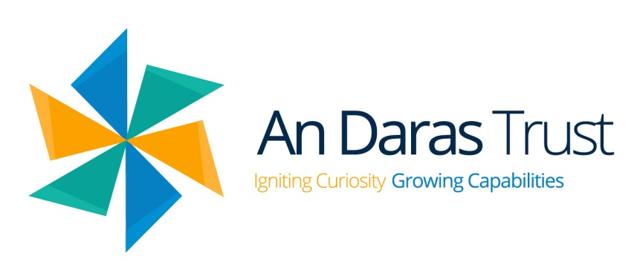
An Daras Multi Academy Trust

Data Privacy Notice for Staff

Version: 1.4
Last Updated: 14/05/2026

We, An Daras Multi Academy Trust registered at Unit 4 Tamar Business Park, Pennygillam Way, Pennygillam Industrial Estate, Launceston, Cornwall, PL15 7ED, are the ‘Data Controller’ for the purposes of UK data protection law. Our Data Protection Officer is Glyn Pascoe (see ‘Contact us’ section below).

What is a ‘privacy notice’?

A privacy notice is often called a ‘fair processing notice’ and is designed to inform individuals when data about them is collected, held and processed.

Typical examples of personal data are:

- Contact details such as name, address, phone numbers, email addresses
- Date of birth
- Marital status
- Gender
- Country of birth
- National Insurance number
- Emergency contact information
- HR related aspects such as salary, tax status, annual leave, pension and benefits, recruitment information including right to work documentation, references, CV and any other documents relating to the recruitment process
- Qualifications and employment records, including work history, working hours along with training and professional memberships
- Financial details such as bank account information
- Work-related performance information including supporting evidence relating to disciplinary procedures, absence and related data
- Supporting collateral for the above, e.g. driving license, passport, birth certificate, photographs
- CCTV footage collected from our site(s)
- Usage data relating to interactions with our IT systems

The above should be viewed as a non-exhaustive list and additional data may be stored where it is deemed relevant.

We may also collect, store and use information about you that falls into ‘special categories’ of more sensitive personal data. This includes information about (where applicable):
- Diversity and equal opportunity monitoring information – this can include race, ethnicity, religious beliefs, sexual orientation and political opinions
- Trade union membership
- Health, including any medical conditions, and sickness records
We may also collect, use, store and share (when appropriate) information regarding criminal convictions and offences.
We may also hold data about you that we have received from other organisations, including other education institutes, social services and the Disclosure and Barring Service (DBS) in respect of criminal offence information.

What is the purpose of holding the data?

- To enable financial transactions e.g. payroll and/or billing along with modelling
- Statutory reporting e.g. to demonstrate equal opportunities employment
- To support efficient administration (e.g. performance reviews and workforce data)
- To provide safe recruitment in line with government/group/local authority best practise
- Support the work of the School Teachers’ Review Body

Use of personal data in automated decision making and profiling?

We do not process any personal data through automated decision making or profiling.

Use of personal data for marketing?

Where consent has been received, we may send marketing and information by email, SMS or post promoting Multi Academy Trust events, campaigns, charitable causes or services that may be of interest.

To opt out of receiving such communications please contact the Data Protection Representative.

What is our lawful purpose?

Data must only be collected and processed when allowable by law. Typically this is when:

- We are required to hold / process data to fulfil a contract or deliver a service
- We are required to hold / process data to comply with legal obligations
- We are required to hold / process data to comply with your vital interests
- It is in the public interest to do so

Where we process your personal data to safeguard the welfare of pupils or to respond to an emergency, we may rely on 'recognised legitimate interests' as our lawful basis under the Data (Use and Access) Act 2025. This means we can share necessary personal data quickly in urgent situations without needing to complete a separate balancing test. We will always limit any sharing to what is strictly necessary.

In addition to the above, it is allowable to hold/process personal data when we have received explicit consent to do so and/or to protect your or someone else’s vital interests.

Where you have provided us with consent to use your data, you may withdraw this consent at any time. We will make this clear when requesting your consent and explain how you go about withdrawing consent if you wish to do so.
Some of the reasons listed above for collecting and using personal information about you overlap, and there may be several grounds which justify the Multi Academy Trust’s use of your data.
Processing criminal convictions and sensitive information; we collect, use and hold sensitive information such as criminal convictions on the lawful basis of contract, legal obligation and public task.

What is our basis for using special category data?

We only collect, store and process special category data when we have both a lawful basis and one of the below conditions for processing as set out in UK data protection law:
- Explicit consent has been obtained
- Protecting an individual’s vital interests in emergency cases where you are physically or legally incapable of giving consent
- The data has already been made public by you
- Processing for legal claims
- Processing ir for substantial public interest as defined in legislations
- Processing for health or social care purposes, and the processing is done by or under the direction of a health or social work professional or by another person obliged to confidentially under law
- Processing for public health reasons, and the processing is done by or under the direction of a health professional or by another person obliged to confidentially under law
- Processing for archiving purposes, scientific or historical research purposes or for statistical purposes and the processing is in the public interest.
- Performing an obligation or right in relation to employment, social security or social protection law

Criminal offence data is only collected, stored and processed when we have both a lawful basis and one of the below conditions for processing as set out in UK data protection law:
- Consent has been obtained
- Protecting an individual’s vital interests in emergency cases where you are physically or legally incapable of giving consent
- The data has already been made public by you
- Processing it for or in connection with legal proceedings, to obtain legal advice or exercise or defence of establishment legal rights
- Processing for reasons of substantial public interest as defined in legislation

How is information collected?

Personal data will fall into two categories: mandatory (in as much as you must comply with the request to provide the data) and optional (where there is a choice whether to supply information or not). As a Data Controller, we must highlight to you which of the above scenarios is applicable.

Most of the data we hold about you will come from you, but we may also hold data about you from:
- Local authorities
- Government departments or agencies
- Police, courts, tribunals

How is data stored?

Personal data is kept secure and may only be used for the purposes relevant to administering your employment. At the point of your employment being terminated by either party, the data will be subject to our standard retention period followed by secure disposal.

A copy of this schedule can be obtained from the Information and Records Management Society’s Toolkit for Schools.

How we share your data

Data will not be shared with any third party without your consent unless either allowable by law or indicated as part of our policies. Assuming either of the above apply, data can be shared with:

- Central government and our local authority (Cornwall or Devon) – to meet our legal obligations to share certain information with them, such as safeguarding concerns
- The Department for Education – to meet our legal obligations to share certain information with it, such as workforce census returns
- Our regulator Ofsted – to meet our legal obligations such as safeguarding and assessment monitoring data etc.
- Suppliers and service providers – to enable them to provide the service we have contracted them for such as contact information for text / SMS / app messaging services
- Financial organisations – to enable them to provide the service we have contracted them for, such as bank account details to enable paying of invoices and monthly pay runs etc.
- Our auditors – to meet our legal obligations and to assess the quality of our services, such as pay-related information
- Trade unions and associations – to meet our legal obligations, such as safeguarding and HR employment aspects
- Professional advisers and consultants – to support pupil learning and enable them to provide the service we have contracted them for, such as training needs/support and performance management
- Health authorities – to meet our public task and vital interests of our staff.
- Health and social welfare organisations – to meet our public tasks and vital interests of our staff.
- Police forces, courts, tribunals – to meet our legal obligations to share certain information with them, such as safeguarding
- Employment and recruitment agencies – to support safer recruitment obligations, such as number of days absent, safeguarding and any active disciplinary on file

Some of the suppliers and service providers we use may process data outside the United Kingdom, including in the United States. Where this happens, we ensure that appropriate safeguards are in place as required by UK data protection law, including where applicable the UK Extension to the EU-US Data Privacy Framework.

How can I see what personal information is held about me? Your rights

To gain access to a report of the data held about you, please complete a ‘subject access request’. If we do hold information about you we will provide the following information:
- A description of the data
- A reason for holding the data
- Where we obtained the data if not from you
- How long the data will be retained for
- Whether the data has been shared and with whom
- Whether any automated decision-making has been applied
- A copy of the data in an intelligible format
Upon receiving the request we will respond within one calendar month. Where a request is complex, we may extend this by up to a further two months and will notify you of this within the first month. To request access please contact your academy’s Data Protection Representative.

Please note that we will only conduct searches that are reasonable and proportionate in scope. If we need further information from you to process your request, we may pause the response period and will let you know what is needed.

Other rights

As a data subject, you have the right to:
- Formally object to the use of your data if it is likely to cause or result in damage, upset or distress
- In certain circumstances have inaccurate data corrected, removed or restrictions placed on its processing
- In certain circumstances have the data we hold about you deleted or destroyed
- In certain circumstances, be notified of a data breach
- Claim compensation for damages caused by a breach of the data protection regulations
- Make a data protection complaint directly to us using our complaints process (see Complaints process section), and if unresolved, to the Information Commissioner's Office (ICO)
- Object to the use of your data in decisions being made by automated processes
- Prohibit your data being used to send direct marketing
To exercise any of these rights, please contact your academy’s Data Protection Representative (DPR) email account – dpr@andaras.org

Complaints process

You have a statutory right to raise a data protection complaint directly with us. You can make a complaint in any of the following ways: speak to any member of staff; telephone the school office; visit the school in person; or write to or email the DPR at the address in the Contact Us section. We will acknowledge your complaint within 30 days and aim to resolve it without undue delay, keeping you informed throughout. If you remain unhappy with our response, you can refer your complaint to the ICO:

- Via their web form at: https://ico.org.uk/make-a-complaint/
- Via live chat on the ICO website
- By calling: 0303 123 1113
- In writing to: Information Commissioner’s Office, Wycliffe House, Water Lane, Wilmslow, Cheshire, SK9 5AF

Contact us
If you have any questions, concerns or would like more information about anything mentioned in this privacy notice, please in the first instance contact your academy’s Data Protection Representative (DPR) email account.
If you feel your concern has not been answered or you have an issue that needs to be escalated please contact our Data Protection Officer (DPO).
Multi Academy Trust’s Data Protection Representative email account:
DPR@andaras.org

Data Protection Officer:
Glyn Pascoe DPO@ict4.co.uk

