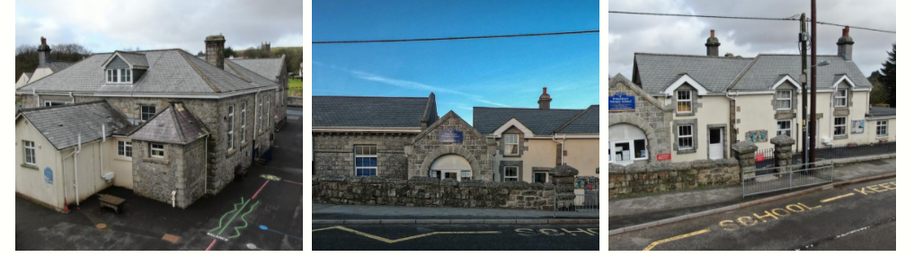

Princetown Community Primary School
"Inspiring lifelong learners in our community"
The Primary School
History
The school was built in 1874 and was known as 'The Prison Officers School' as it was for the children of the prison officers only. The men had to pay for each child to attend, so in large families, not all children were able to attend. Convicts built the school and carried out daily cleaning, which included the lighting of the peat fires in the classrooms each morning. They also had to spread and rake screened sand over the playground, which was originally called the parade ground. This continued into the 1920s. The men who carried out the cleaning/maintenance were known as the scavenging party and were chained together with a cart containing their rations. They were carefully guarded by armed officers.
Now
We are proud to be a community school and we want to enable children to take an active role in where they live. We are committed to developing the whole child with a real focus on what each individual child needs to succeed. The curriculum we have developed, follows what is set out in the National Curriculum and it is also personalised to the children in our community.
Every Friday afternoon, the whole school takes part in forest school activities. We go to a local private wood where the children learn new skills, take part in group activities and have a chance to explore.
Resilience – we build children’s resilience in order to help them become absorbed in their learning. They begin to understand when they need a brain break to refresh themselves.
Challenge – when children are challenged it helps them learn, problem solve and feel success.
Creativity – being creative means being able to use their imagination and think of their own ideas, trying new methods and thinking of different ways to complete tasks.
Self-Awareness – we aim to teach children how to be reflective and how they learn best
Interdependence – this allows children to understand when it is good to work as a team and when best to work independently. They learn to listen to and respect other views.
WE ARE COMMITED TO THE SAFEGUARDING OF ALL CHILDREN WITHIN THE CARE OF OUR SCHOOL.

