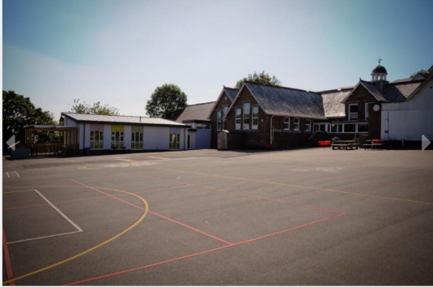

Windmill Hill Academy
“Inspiring Passionate Life Long Learners”
The Primary School
Windmill Hill Academy is at the heart of our local community and we strive to work closely with families of the school and the local community to maintain a successful partnership that thrives on our values and vision. Windmill Hill sits on a wonderful site in the middle of Launceston. At Windmill Hill Academy, we make the most outdoor learning opportunities, both in our school grounds and within the local area.
At Windmill Hill Academy, we all believe that Primary Education is an important stage in any child's life. Their experience at our school will lay the foundation for all their future learning and we strive to give every child the best start possible in their school careers.
This, of course, is dependent on many factors and one of the most important of these is the relationship and partnership between home and school. I hope we will work closely together throughout your child's time with us and that you will always feel welcome in school. There are many ways in which you can become involved in the life of the school and I hope you will feel part of our school community.
We are committed to this by developing our ‘Learning Sails’ with Pupils:
• Reflection- We ask all learners to give thought or consideration on their actions and learning.
• Self-awareness- We encourage self-awareness and having a conscious knowledge of one’s own character, feelings and learning. We encourage learners to know where they are with their learning and their next steps.
• Curiosity-We inspire all learners to have strong desire to know or learn something, questioning their learning experiences to find out more.
• Resilience and Tenacity-We promote the capacity to recover quickly from difficulties or challenge. We encourage all to be very determined and show determination despite the challenge.
• Connect-We promote learning where connections can be made, where children can relate new and old learning.
WE ARE COMMITED TO THE SAFEGUARDING OF ALL CHILDREN WITHIN THE CARE OF OUR SCHOOL.

